## S.5.1 Sensitivity analysis

We performed a sensitivity analysis on two parameters: the dispersal tail parameter (a = 2) and the fitness curve asymmetry parameter (α = 0.1). Each was varied by ±10% and ±25% to assess their effects on mean alpha diversity, mean population size and gamma diversity.

# **S.5.1.1 Dispersal tail parameter**

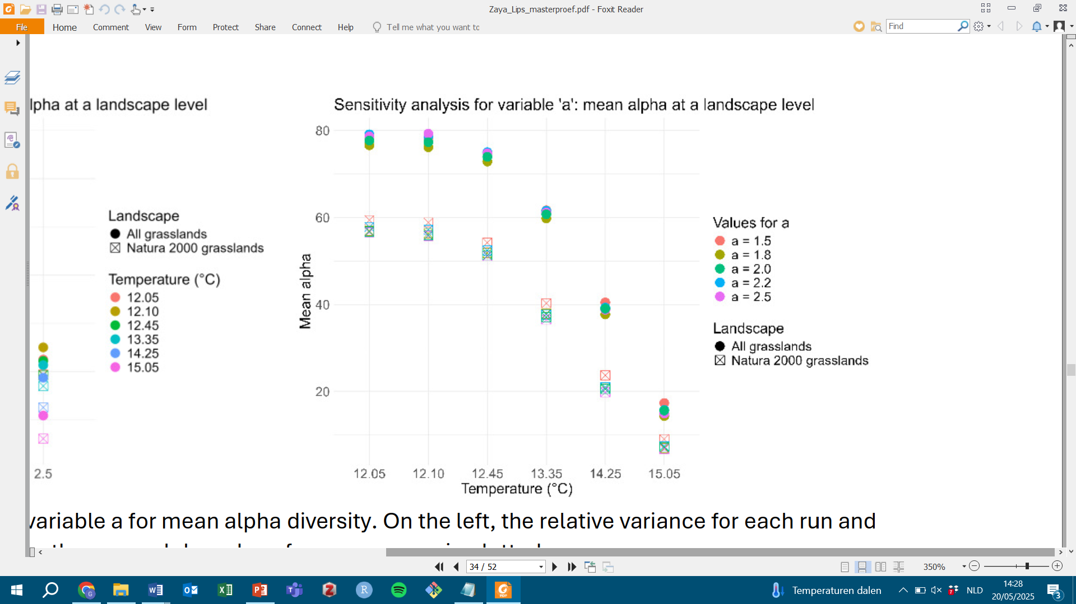Alpha diversity, gamma diversity and population size all showed similar trends regardless of which value was used to determine the tail of the dispersal curves (Figures S.5.1.1 – S.5.1.3). Additionally, there was no considerable variance between the different results, except some noticeable differences in gamma diversity. Nevertheless, the parameter seems robust and does not affect the interpretation of the results in a meaningful way.

*Figure S.5.1.1: sensitivity analysis for the effect of dispersal tail parameter* a *on alpha diversity. Each dot represents the outcome for a specific value of* a *for each temperature and landscape scenario.*

*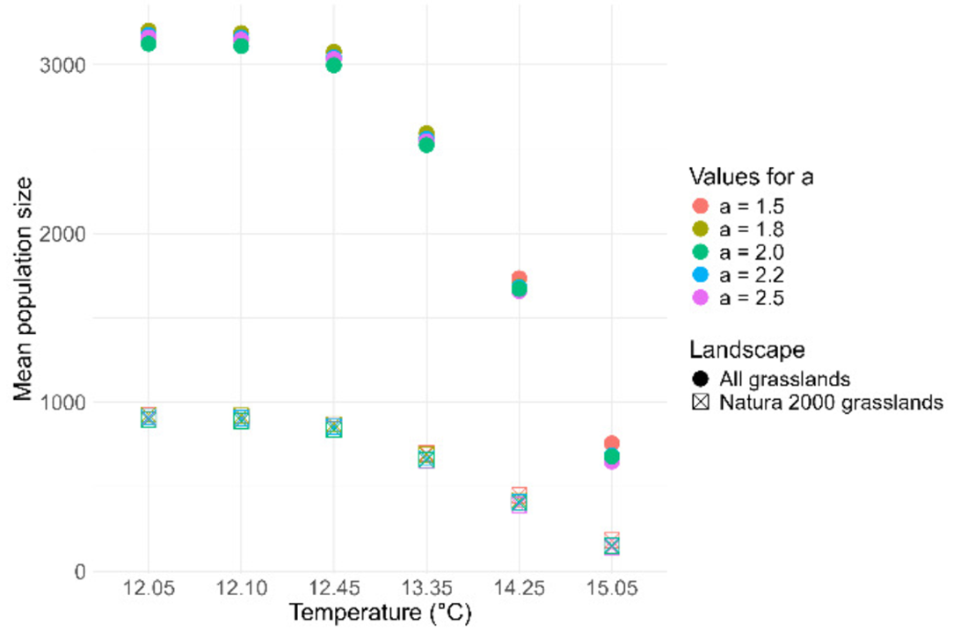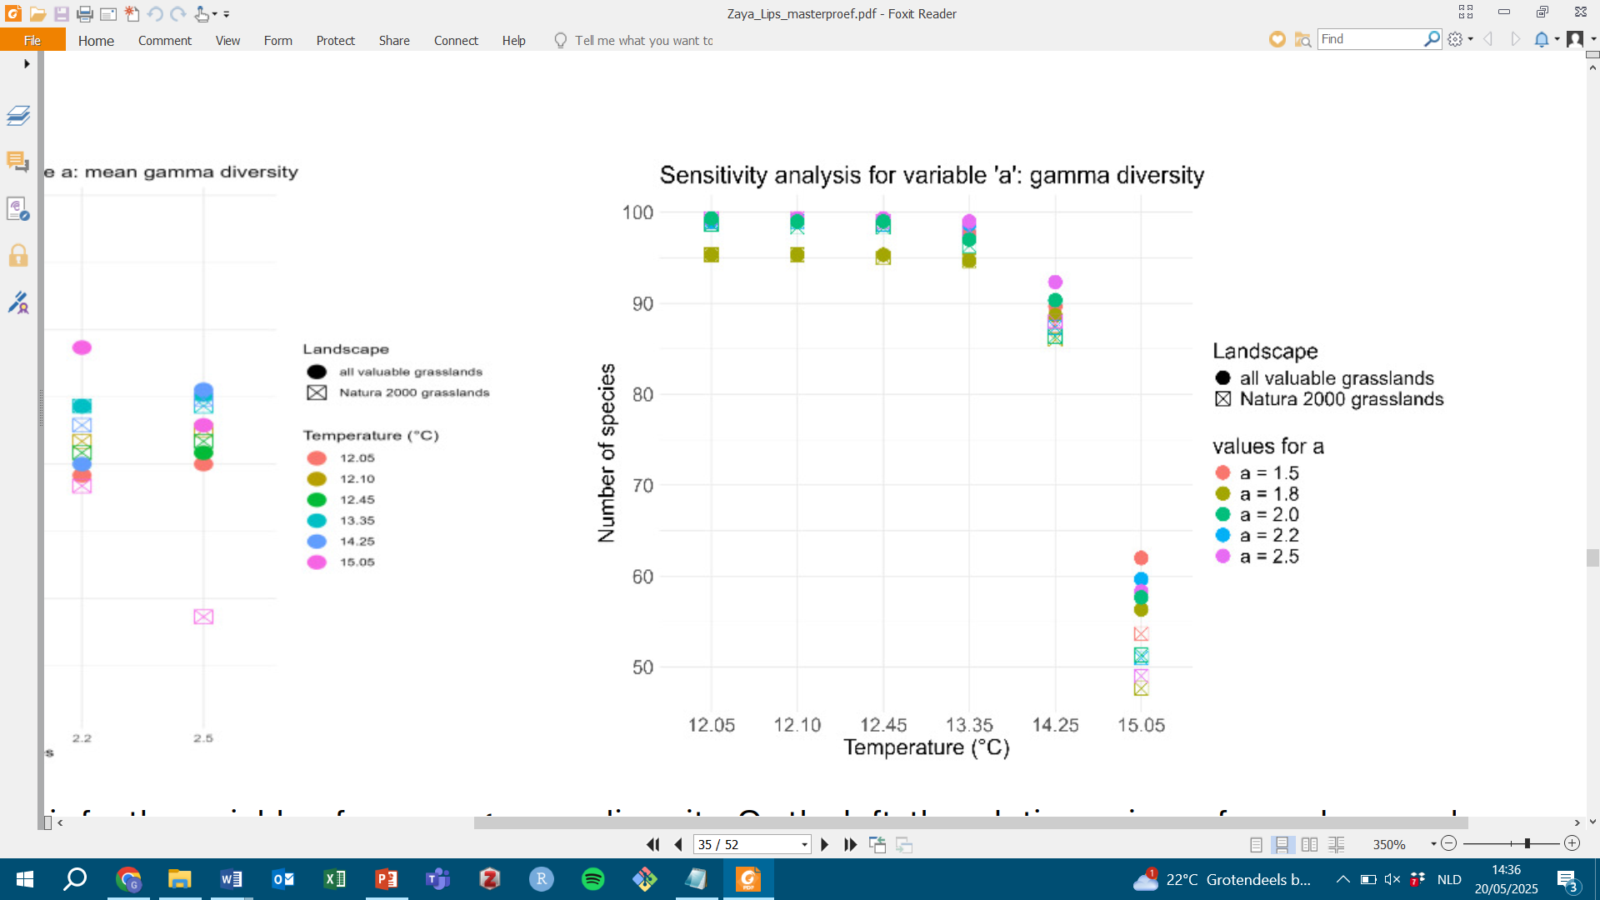Figure S.5.1.2: sensitivity analysis for the effect of dispersal tail parameter* a *on gamma diversity. Each dot represents the outcome for a specific value of* a *for each temperature and landscape scenario.*

*Figure S.5.1.3: sensitivity analysis for the effect of dispersal tail parameter* a *on mean population size. Each dot represents the outcome for a specific value of* a *for each temperature and landscape scenario.*

# **S.5.1.2 Fitness curve asymmetry parameter**

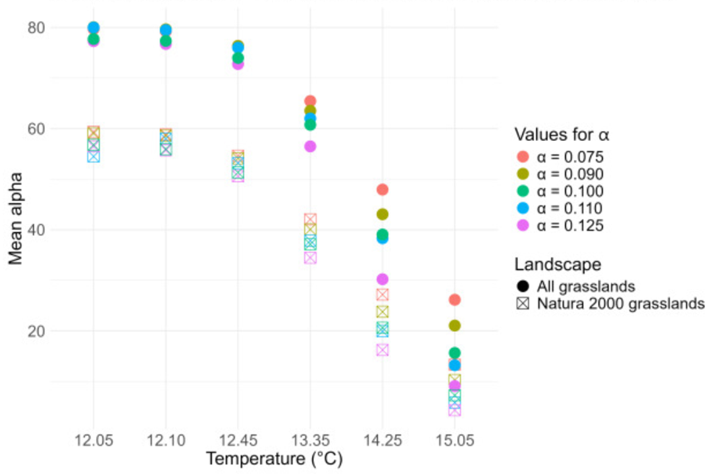Alpha diversity, gamma diversity and population size all showed similar trends regardless of which value was used to determine the asymmetry of fitness curves (Figures S.5.1.4 – S.5.1.6). There was considerable variance between results, especially at the most extreme temperature scenarios. Nevertheless, the parameter seems robust and does not affect the interpretation of the results in a meaningful way.

*Figure S.5.1.4: sensitivity analysis for the effect of fitness curve asymmetry parameter* α *on alpha diversity. Each dot represents the outcome for a specific value of* α *for each temperature and landscape scenario.*

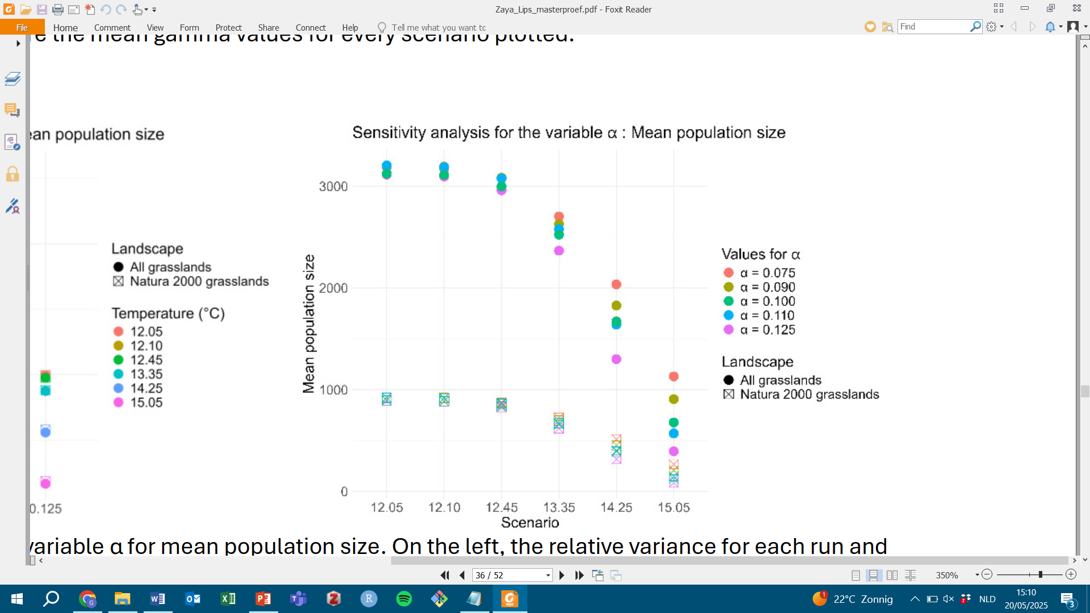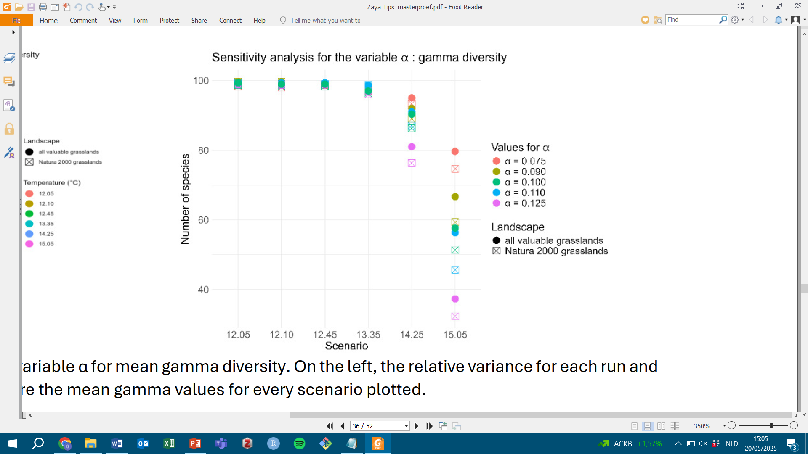*Figure S.5.1.5: sensitivity analysis for the effect of fitness curve asymmetry parameter* α *on gamma diversity. Each dot represents the outcome for a specific value of* α *for each temperature and landscape scenario.*

*Figure S.5.1.6: sensitivity analysis for the effect of fitness curve asymmetry parameter* α *on mean population size. Each dot represents the outcome for a specific value of* α *for each temperature and landscape scenario.*